

Dept. of Computer Science

Aryabhatta College
(University of Delhi)

Practical File
based on

DSE: Data Mining
Session 2025

Supervisor
Gagandeep Sharma

Submitted by
Name: Ujjwal Jaiswal
College Roll No: CSC/24/56
Examination Roll No: 24059570005
Semester: 3rd
Course: B.Sc. (H) Computer Science
PRACTICAL 1
Question:
Apply data cleaning techniques on any dataset (e,g, wine dataset). Techniques may include handling missing values, outliers, inconsistent values. A set of validation rules can be prepared based on the dataset and validations can be performed.
Source Code:
import pandas as pd
import numpy as np

# Load the dataset
df=pd.read_csv('car_sales_data.csv')

# Initial exploration
print("First 5 rows:")
print(df.head())

# Data types and summary statistics
print("\nData types of columns:")
print(df.dtypes)

# Summary statistics and missing values
print("\nSummary statistics:")
print(df.describe(include='all'))
print("\nMissing values in each column:")
print(df.isnull().sum())

# If missing values are few, drop rows; otherwise, fill with appropriate values
threshold = 0.05 * len(df) # 5% of total rows

# Handling missing values
for col in df.columns:
missing_count = df[col].isnull().sum()
if missing_count > 0:
if missing_count < threshold:
df = df.dropna(subset=[col])
print(f"Dropped rows with missing values in '{col}'.")
else:
if df[col].dtype == 'object':
df[col] = df[col].fillna(df[col].mode()[0])
print(f"Filled missing values in '{col}' with mode.")
else:
df[col] = df[col].fillna(df[col].median())
print(f"Filled missing values in '{col}' with median.")

# Check for duplicates
print("\nUnique values in categorical columns:")
categorical_cols = df.select_dtypes(include=['object']).columns
for col in categorical_cols:
print(f"\nColumn '{col}':")
print(df[col].unique())

# Data validation rules
# Rule 1: 'Year of manufacture' should be between 1980 and current year
current_year = pd.Timestamp.now().year
if 'Year of manufacture' in df.columns:
invalid_years = ~df['Year of manufacture'].between(1980, current_year)
print(f"\nRows with invalid 'Year of manufacture': {df[invalid_years].shape[0]}")
print(df[invalid_years][['Year of manufacture']])

# Rule 2: 'Mileage' and 'Price' should be positive numbers
for col in ['Mileage', 'Price']:
if col in df.columns:
invalid = df[col] <= 0
print(f"\nRows with non-positive '{col}': {df[invalid].shape[0]}")
print(df[invalid][[col]])

# Rule 3: 'Engine size' should be between 0.6 and 8.0 liters (example range)
if 'Engine size' in df.columns:
invalid_engine = ~df['Engine size'].between(0.6, 8.0)
print(f"\nRows with unrealistic 'Engine size': {df[invalid_engine].shape[0]}")
print(df[invalid_engine][['Engine size']])

# After identifying issues, you can choose to drop or correct them
df.to_csv('cleaned_car_sales_data.csv', index=False)
print("\nCleaned data saved to 'cleaned_car_sales_data.csv'.")

Output:
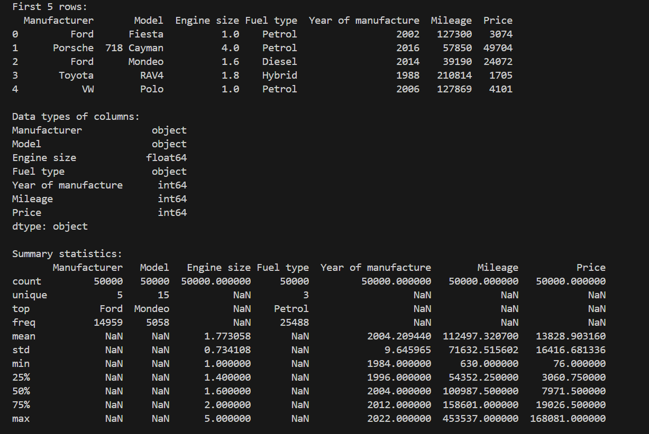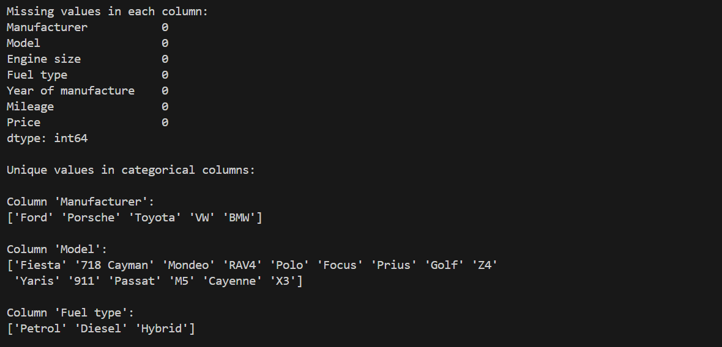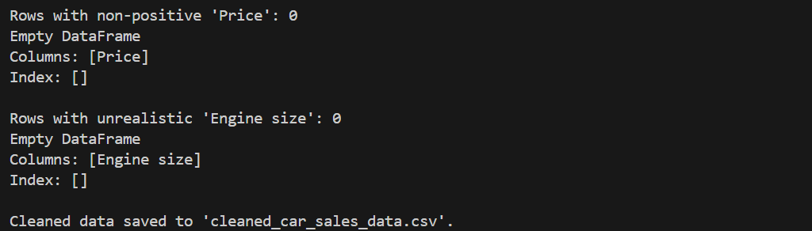
PRACTICAL 2
Question:
Apply data pre-processing techniques such as standardization/normalization, transformation, aggregation, discretization/binarization, sampling etc. on any dataset
Source Code:
import pandas as pd
import numpy as np
from sklearn.preprocessing import StandardScaler

# Load the dataset
data = pd.read_csv('cleaned_car_sales_data.csv')

# Assuming data cleaning has been done as per Practical-1_CSC-24-56.py
scaler = StandardScaler()
data_scaled = pd.DataFrame(scaler.fit_transform(data.select_dtypes(include=[np.number])), columns=data.select_dtypes(include=[np.number]).columns)

# Add a new column with log-transformed 'Price' (if 'Price' exists)
if 'Price' in data_scaled.columns:
data_scaled['log_Price'] = np.log1p(data_scaled['Price'])
data_scaled.drop(columns=['Price'], inplace=True)

# Display the first few rows of the scaled data
print(data_scaled.head())

# Aggregate the scaled data by 'Manufacturer' and calculate mean of each feature
if 'Manufacturer' in data.columns:
aggregated_data = data_scaled.copy()
aggregated_data['Manufacturer'] = data['Manufacturer'].values
manufacturer_agg = aggregated_data.groupby('Manufacturer').mean()
print(manufacturer_agg)
else:
print("Column 'Manufacturer' not found in the dataset.")

# Discretize the 'log_Price' column into 4 bins (quartiles) if it exists
if 'log_Price' in data_scaled.columns:
data_scaled['log_Price_bin'] = pd.qcut(data_scaled['log_Price'], q=4, labels=['Low', 'Medium', 'High', 'Very High'])
print(data_scaled[['log_Price', 'log_Price_bin']].head())
else:
print("'log_Price' column not found for discretization.")
# Randomly sample 10 rows from the scaled data
sampled_data = data_scaled.sample(n=10, random_state=42)
print("Randomly sampled data:")
print(sampled_data)
# Save the processed data to a new CSV file
data_scaled.to_csv('processed_car_sales_data.csv', index=False)

Output:
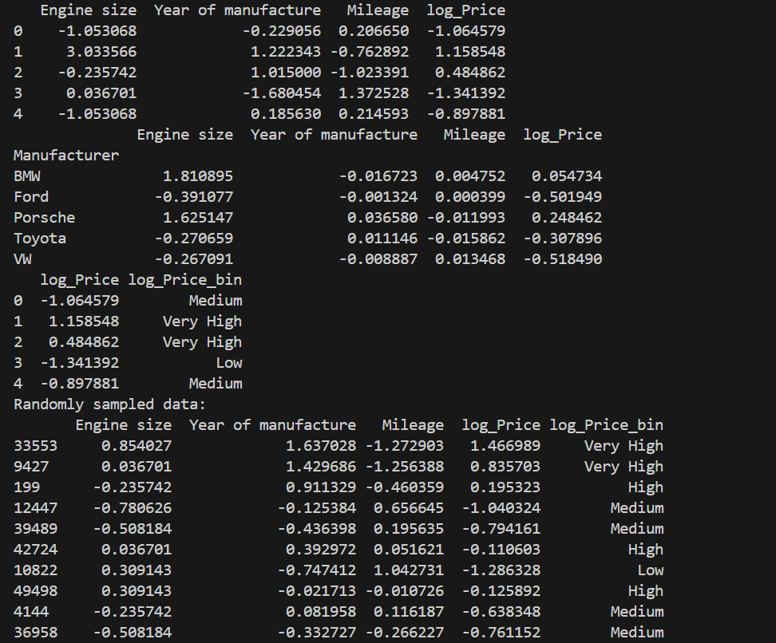

PRACTICAL 3
Question:
Run Apriori algorithm to find frequent item sets and association rules on 2 real datasets and use appropriate evaluation measures to compute correctness of obtained patterns
a) Use minimum support as 50% and minimum confidence as 75%
b) Use minimum support as 60% and minimum confidence as 60 %
Source code:
import pandas as pd
from mlxtend.frequent_patterns import apriori, association_rule
from mlxtend.preprocessing import TransactionEncoder

# Funtion to run Apriori algorithm and display results
def run_apriori(df, min_sup, min_conf):
print(f"\nRunning Apriori with Support = {min_sup}, Confidence = {min_conf}\n")

frequent_items = apriori(df, min_support=min_sup, use_colnames=True)

if frequent_items.empty:
print("No frequent itemsets found. Try lowering support.")
return

print("Frequent Itemsets:")
print(frequent_items)

rules = association_rules(frequent_items, metric="confidence", min_threshold=min_conf)

if rules.empty:
print("No association rules found. Try lowering confidence.")
return

print("\nAssociation Rules:")
print(rules[['antecedents', 'consequents', 'support', 'confidence', 'lift']])

# LOAD DATASET (Groceries dataset)
input_file_path = "C:\\Users\\anshu\\OneDrive\\Desktop\\College\\DSE (Discipline Specific Elective Courses)\\" \
"Semester 3 - Data Mining I\\Practicals\\Datasets\\Groceries_dataset.csv"
groceries = pd.read_csv(input_file_path)

# Convert dataset: item per row → list per transaction
basket = (groceries.groupby(['Member_number','Date'])['itemDescription']
.apply(list)
.reset_index())

# Convert to one-hot encoded format
te = TransactionEncoder()
te_data = te.fit(basket['itemDescription']).transform(basket['itemDescription'])
df = pd.DataFrame(te_data, columns=te.columns_)

# Ask user for min support and confidence
min_sup = float(input("Enter minimum support (e.g., 0.50): "))
min_conf = float(input("Enter minimum confidence (e.g., 0.75): "))

# Run Apriori
run_apriori(df, min_sup, min_conf)

Output:
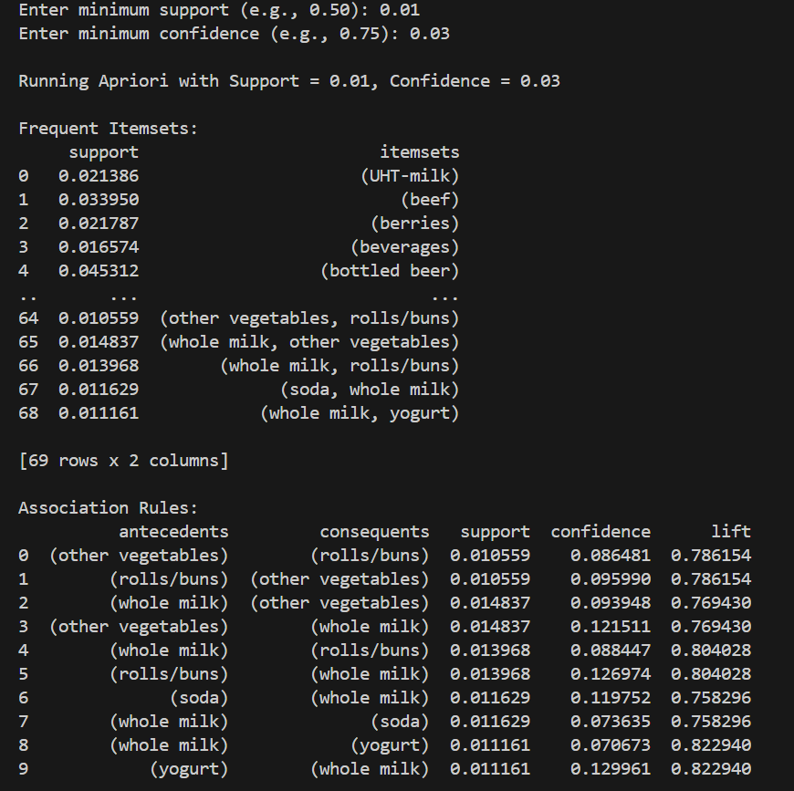
PRACTICAL 4
Question:
Use Naive bayes, K-nearest, and Decision tree classification algorithms and build classifiers on any two datasets. Divide the data set into training and test set. Compare the accuracy of the different classifiers under the following situations: I.
a) Training set = 75% Test set = 25%
b) Training set = 66.6% (2/3rd of total), Test set = 33.3% II.
Training set is chosen by
i) hold out method ii) Random subsampling iii) Cross-Validation.
Compare the accuracy of the classifiers obtained. Data needs to be scaled to standard format.
Source Code:
# classification_two_datasets_user_files.py
import pandas as pd
import numpy as np
from sklearn.model_selection import train_test_split, cross_val_score, StratifiedKFold
from sklearn.preprocessing import StandardScaler, OneHotEncoder
from sklearn.compose import ColumnTransformer
from sklearn.pipeline import Pipeline
from sklearn.impute import SimpleImputer
from sklearn.naive_bayes import GaussianNB
from sklearn.neighbors import KNeighborsClassifier
from sklearn.tree import DecisionTreeClassifier
from sklearn.metrics import accuracy_score

# Paths to your uploaded files
FRUIT_PATH = r"C:\Users\anshu\OneDrive\Desktop\College\DSE (Discipline Specific Elective Courses)\Semester 3 - Data Mining I\Practicals\Datasets\fruit_classification_dataset.csv"
BREAST_PATH = r"C:\Users\anshu\OneDrive\Desktop\College\DSE (Discipline Specific Elective Courses)\Semester 3 - Data Mining I\Practicals\Datasets\breast_cancer_classification_dataset.csv"

# Settings
RS_REPEATS = 5 # random subsampling repeats
RANDOM_STATE = 42

# Utility functions
def build_preprocessor(X):
num_cols = X.select_dtypes(include=['int64', 'float64']).columns.tolist()
cat_cols = X.select_dtypes(include=['object', 'category']).columns.tolist()

numeric_transformer = Pipeline(steps=[
('imputer', SimpleImputer(strategy='median')),
('scaler', StandardScaler())
])

categorical_transformer = Pipeline(steps=[
('imputer', SimpleImputer(strategy='most_frequent')),
('ohe', OneHotEncoder(handle_unknown='ignore', sparse_output=False))
])

return ColumnTransformer(transformers=[
('num', numeric_transformer, num_cols),
('cat', categorical_transformer, cat_cols)
])

def evaluate_holdout(X, y, pipeline, train_size, random_state=RANDOM_STATE):
X_train, X_test, y_train, y_test = train_test_split(
X, y, train_size=train_size, stratify=y, random_state=random_state)
pipeline.fit(X_train, y_train)
y_pred = pipeline.predict(X_test)
return accuracy_score(y_test, y_pred)

def evaluate_random_subsampling(X, y, pipeline, train_size, repeats=RS_REPEATS):
accs = []
for i in range(repeats):
rs = i * 7 + 1
try:
acc = evaluate_holdout(X, y, pipeline, train_size=train_size, random_state=rs)
accs.append(acc)
except Exception as e:
# If something fails (rare), skip that repeat
print(f"Random subsample repeat {i} failed: {e}")
if len(accs) == 0:
return np.nan, np.nan
return np.mean(accs), np.std(accs)

def evaluate_cv(X, y, pipeline, folds=5):
cv = StratifiedKFold(n_splits=folds, shuffle=True, random_state=RANDOM_STATE)
try:
scores = cross_val_score(pipeline, X, y, cv=cv, scoring='accuracy', n_jobs=-1)
return np.mean(scores), np.std(scores)
except Exception as e:
print("Cross-validation failed:", e)
return np.nan, np.nan

# Classifiers and splits
classifiers = {
'NaiveBayes': GaussianNB(),
'KNN': KNeighborsClassifier(n_neighbors=5),
'DecisionTree': DecisionTreeClassifier(random_state=RANDOM_STATE)
}
train_sizes = {
'75_25': 0.75,
'66.6_33.3': 2/3
}

results = []

# Function to run full experiment on one dataset
def run_experiments(dataset_name, X, y):
print(f"\n=== Running experiments for: {dataset_name} ===")
preprocessor = build_preprocessor(X)
for clf_name, clf in classifiers.items():
for split_label, train_size in train_sizes.items():
pipeline = Pipeline([('pre', preprocessor), ('clf', clf)])
# Hold-out
try:
hold_acc = evaluate_holdout(X, y, pipeline, train_size=train_size, random_state=RANDOM_STATE)
except Exception as e:
print(f"Holdout failed for {dataset_name}, {clf_name}, {split_label}: {e}")
hold_acc = np.nan
# Random subsampling
rs_mean, rs_std = evaluate_random_subsampling(X, y, pipeline, train_size=train_size, repeats=RS_REPEATS)
# Cross-validation
cv_mean, cv_std = evaluate_cv(X, y, pipeline, folds=5)

results.append({
'Dataset': dataset_name,
'Classifier': clf_name,
'Split': split_label,
'Holdout_Accuracy': round(float(hold_acc), 4) if not pd.isna(hold_acc) else np.nan,
'RandSub_mean': round(float(rs_mean), 4) if not pd.isna(rs_mean) else np.nan,
'RandSub_std': round(float(rs_std), 4) if not pd.isna(rs_std) else np.nan,
'CV_mean': round(float(cv_mean), 4) if not pd.isna(cv_mean) else np.nan,
'CV_std': round(float(cv_std), 4) if not pd.isna(cv_std) else np.nan
})
print(f"{dataset_name} | {clf_name} | {split_label} -> Holdout: {hold_acc:.4f}, RandSub mean: {rs_mean:.4f}, CV mean: {cv_mean:.4f}")

# Dataset 1: Fruit dataset
print("Loading fruit dataset from:", FRUIT_PATH)
df_fruit = pd.read_csv(FRUIT_PATH)
df_fruit = df_fruit.dropna(axis=1, how='all') # drop fully-empty columns
df_fruit = df_fruit.loc[:, ~df_fruit.columns.str.startswith('Unnamed')] # drop 'Unnamed' columns

# expected target: 'fruit_name'
TARGET_FRUIT = 'fruit_name'
if TARGET_FRUIT not in df_fruit.columns:
raise ValueError(f"Target column '{TARGET_FRUIT}' not found in fruit dataset. Columns: {list(df_fruit.columns)}")

X_fruit = df_fruit.drop(columns=[TARGET_FRUIT]).copy()
y_fruit = df_fruit[TARGET_FRUIT].copy()
# factorize target if non-numeric
if y_fruit.dtype == 'object' or y_fruit.dtype.name == 'category':
y_fruit, _ = pd.factorize(y_fruit)

run_experiments("Fruit", X_fruit, y_fruit)

# Dataset 2: Breast cancer dataset
print("\nLoading breast cancer dataset from:", BREAST_PATH)
df_breast = pd.read_csv(BREAST_PATH)
df_breast = df_breast.dropna(axis=1, how='all') # drop fully-empty columns
df_breast = df_breast.loc[:, ~df_breast.columns.str.startswith('Unnamed')] # drop 'Unnamed' columns

# Common breast dataset columns: 'diagnosis' is typical target with 'M'/'B'
TARGET_BREAST = 'diagnosis'
if TARGET_BREAST not in df_breast.columns:
raise ValueError(f"Target column '{TARGET_BREAST}' not found in breast dataset. Columns: {list(df_breast.columns)}")

# Drop id if present (non-feature)
if 'id' in df_breast.columns:
df_breast = df_breast.drop(columns=['id'])

X_breast = df_breast.drop(columns=[TARGET_BREAST]).copy()
y_breast = df_breast[TARGET_BREAST].copy()
# factorize target to numeric labels (M/B -> 0/1)
if y_breast.dtype == 'object' or y_breast.dtype.name == 'category':
y_breast, _ = pd.factorize(y_breast)

run_experiments("BreastCancer", X_breast, y_breast)

# Save & show summary
res_df = pd.DataFrame(results)
print("\n\n=== Final summary ===")
print(res_df)

CLASSIFCATION_RESULTS_CSV_PATH = "C:\\Users\\anshu\\OneDrive\\Desktop\\College\\DSE (Discipline Specific Elective Courses)\\Semester 3 - Data Mining I\\Practicals\\Datasets\\classification_results.csv"

res_df.to_csv(CLASSIFCATION_RESULTS_CSV_PATH, index=False)
print(f"\nSaved results to '{CLASSIFCATION_RESULTS_CSV_PATH}'")
Output:
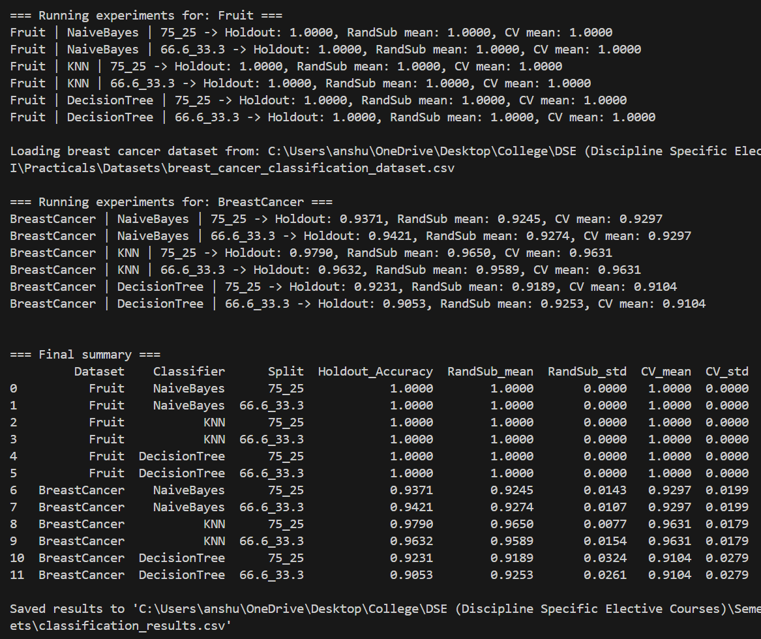

PRACTICAL 5
Question:
Use Simple K-means algorithm for clustering on any dataset. Compare the performance of clusters by changing the parameters involved in the algorithm. Plot MSE computed after each iteration using a line plot for any set of parameters
Source Code:
import numpy as np
import matplotlib.pyplot as plt
from sklearn.datasets import load_wine
from sklearn.preprocessing import StandardScaler

# Load any dataset (using WINE)

data = load_wine()
X = data.data

# Scale features
scaler = StandardScaler()
X = scaler.fit_transform(X)

# Simple K-Means Implementation
def simple_kmeans(X, k=3, max_iter=20):
np.random.seed(42)
n_samples, n_features = X.shape

# Randomly initialize centroids
centroids = X[np.random.choice(n_samples, k, replace=False)]

mse_list = [] # store MSE after each iteration

for i in range(max_iter):

# Assign clusters
distances = np.linalg.norm(X[:, np.newaxis] - centroids, axis=2)
labels = np.argmin(distances, axis=1)

# Compute MSE (mean squared error)
mse = np.mean([np.linalg.norm(X[j] - centroids[labels[j]])**2 for j in range(n_samples)])
mse_list.append(mse)

# Update centroids
new_centroids = np.array([X[labels == c].mean(axis=0) for c in range(k)])

# Stop if centroids do not change
if np.allclose(centroids, new_centroids):
break

centroids = new_centroids

return labels, centroids, mse_list

# Run K-Means with user parameters
k = int(input("Enter number of clusters (e.g., 3): "))
max_iter = int(input("Enter maximum iterations (e.g., 20): "))

labels, centroids, mse_list = simple_kmeans(X, k=k, max_iter=max_iter)

# Plot MSE vs Iterations
plt.plot(range(1, len(mse_list) + 1), mse_list, marker='o')
plt.xlabel("Iteration")
plt.ylabel("MSE")
plt.title(f"K-Means MSE vs Iterations (k={k}, max_iter={max_iter})")
plt.grid(True)
plt.show()

print("\nFinal MSE:", mse_list[-1])
print("Centroids shape:", centroids.shape)

Output:
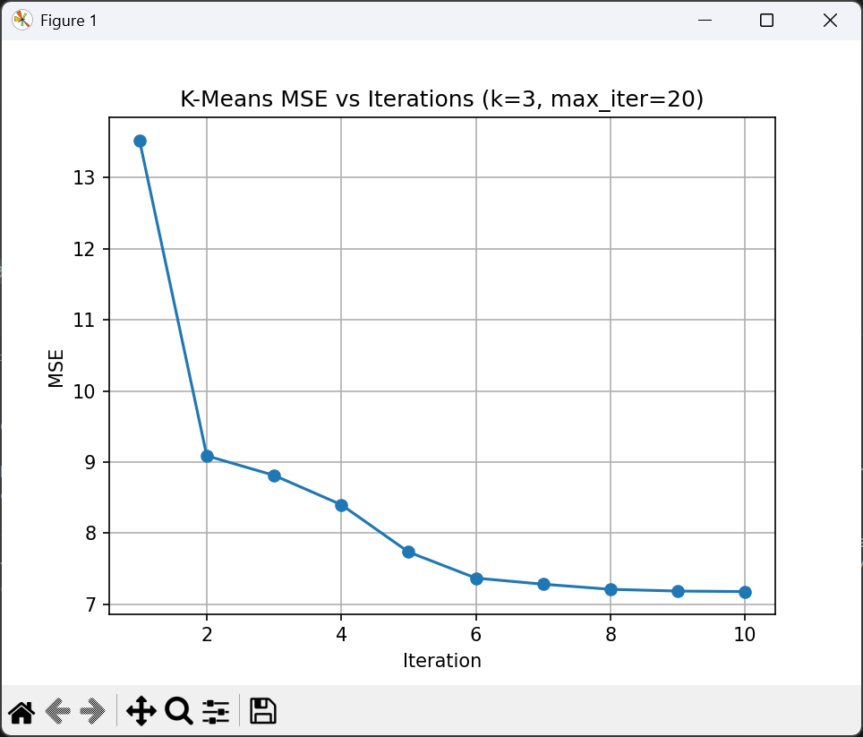

PRACTICAL 6
Question:
Perform density-based clustering algorithm on a downloaded dataset and evaluate the cluster quality by changing the algorithm's parameters.
Source Code:
import pandas as pd
import numpy as np
from sklearn.preprocessing import StandardScaler
from sklearn.cluster import DBSCAN
from sklearn.metrics import silhouette_score
import matplotlib.pyplot as plt

# 1. Load Dataset

INPUT_FILE = r"C:\Users\anshu\OneDrive\Desktop\College\DSE (Discipline Specific Elective Courses)\Semester 3 - Data Mining I\Practicals\Datasets\Mall_Customers.csv"
df = pd.read_csv(INPUT_FILE)

# Use only numeric clustering features
data = df[['Age', 'Annual Income (k$)', 'Spending Score (1-100)']]

# 2. Scale Data

scaler = StandardScaler()
X = scaler.fit_transform(data)

# 3. Try different DBSCAN parameters

eps_values = [0.2, 0.5, 0.8, 1.0]
min_samples_values = [3, 5, 8]

results = []

for eps in eps_values:
for ms in min_samples_values:
db = DBSCAN(eps=eps, min_samples=ms)
labels = db.fit_predict(X)

# Number of clusters (excluding noise)
n_clusters = len(set(labels)) - (1 if -1 in labels else 0)

# Calculate silhouette only if ≥2 clusters exist
if n_clusters >= 2:
score = silhouette_score(X, labels)
else:
score = -1 # invalid

results.append([eps, ms, n_clusters, score])
print(f"eps={eps}, min_samples={ms}, clusters={n_clusters}, silhouette={score}")

# 4. Convert results to DataFrame

results_df = pd.DataFrame(results, columns=["eps", "min_samples", "clusters", "silhouette"])
print("\nParameter Testing Results:\n")
print(results_df)

# 5. Plot clusters for BEST parameter choice

best = results_df.loc[results_df["silhouette"].idxmax()]

best_eps = float(best["eps"])
best_ms = int(best["min_samples"])

print("\nBest Parameters:")
print(best)

# Train DBSCAN with best parameters
db_best = DBSCAN(eps=best_eps, min_samples=best_ms)
labels_best = db_best.fit_predict(X)

# Plot clusters
plt.figure(figsize=(8, 6))
plt.scatter(data['Annual Income (k$)'], data['Spending Score (1-100)'],
c=labels_best, cmap='viridis')
plt.xlabel("Annual Income (k$)")
plt.ylabel("Spending Score (1-100)")
plt.title(f"DBSCAN Clusters (eps={best_eps}, min_samples={best_ms})")
plt.show()

Output:
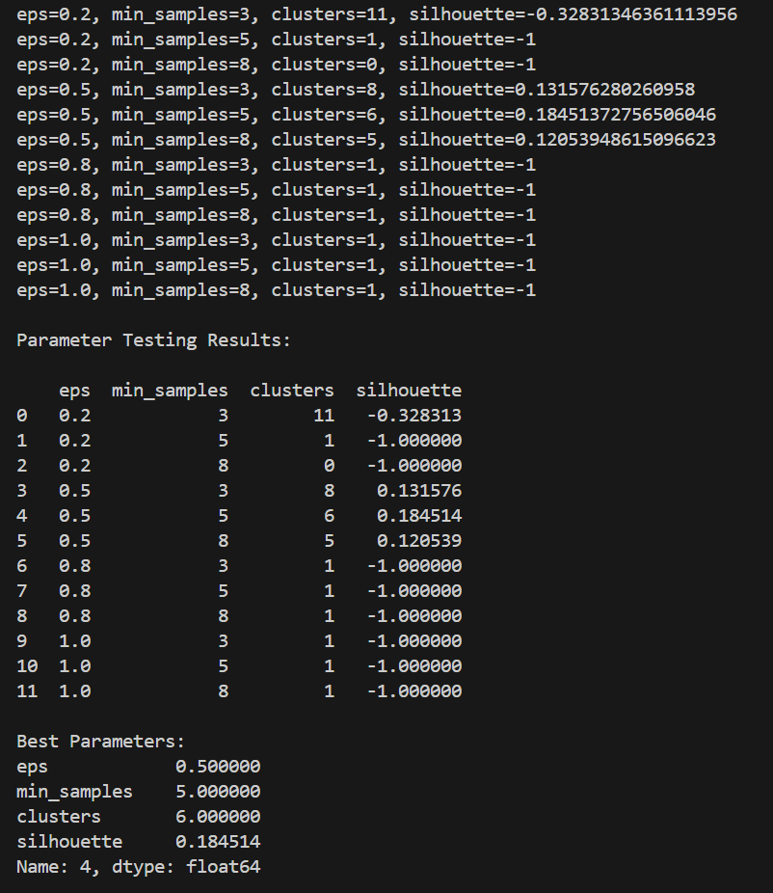

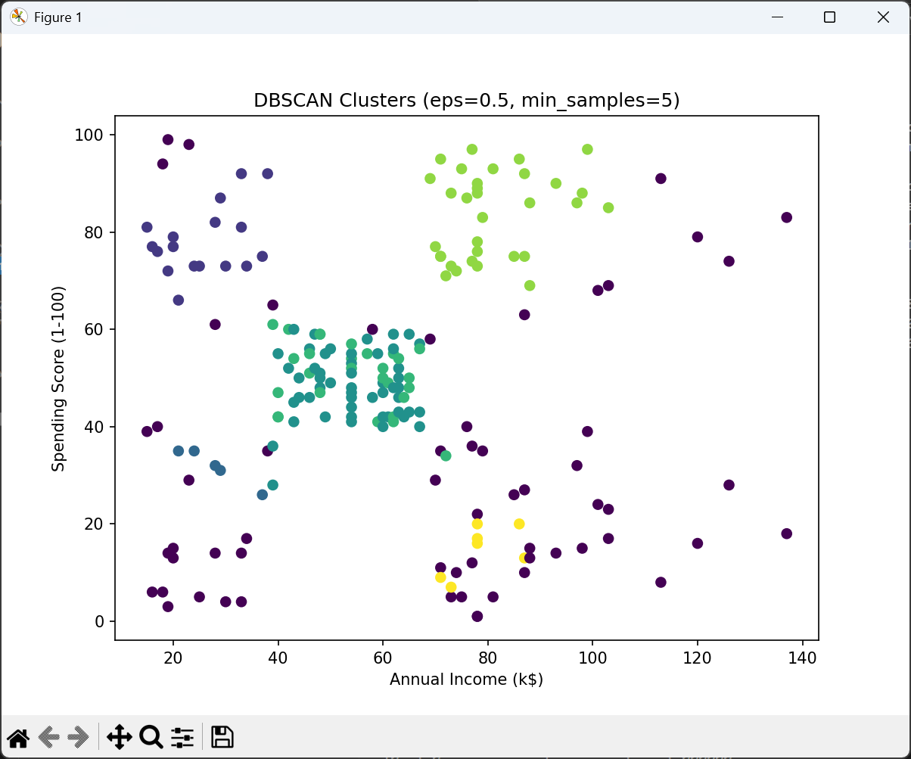

END OF PRACTICAL FILE

